A KPI’S

**1. TOTAL REVENUE**

SELECT sum(total price) AS total_revenue FROM pizza_sales;



**2. AVERAGE ORDER VALUE**

SELECT sum(total_price) / count(distinct order_id) AS avg_order_value FROM pizza_sales;



**3. TOTAL PIZZA SOLD**

SELECT sum(quantity) AS total_sold FROM pizza_sales;



**4. TOTAL ORDER**

SELECT count(distinct order_id) AS total_order FROM pizza_sales;



**5. AVERAGE PIZZA PER ORDER**

SELECT cast(cast(sum(quantity) as decimal(10,2)) / CAST(count(distinct order_id) AS decimal(10,2)) AS decimal(10,2) ) AS avg_pizza_per_order FROM pizza_sales;



**6. Monthly Trend**

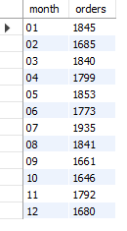

**7. Percentage of Sales by Pizza category**

SELECT pizza_category, sum(total_price) * 100 / (select sum(total_price) from pizza_sales) as PCT FROM pizza_sales

GROUP BY pizza_category;

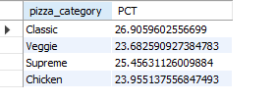

**8.** **Percentage of Sales by Pizza Size**

SELECT pizza_size, cast(sum(total_price) AS decimal(10,2)) AS Total_sales ,cast(sum(total_price) * 100 / (select sum(total_price) FROM pizza_sales) AS decimal (10,2)) AS PCT FROM pizza_sales

GROUP BY pizza_size ORDER BY PCT DESC;

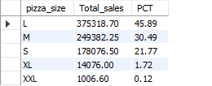

**9. Top 5 Pizza by Revenue**

SELECT pizza_name, sum(total_price) AS Total_Revenue FROM pizza_sales

GROUP BY pizza_name

ORDER BY Total_Revenue desc;

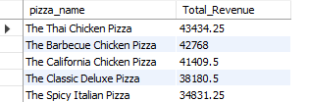

**10. Bottom 5 pizza by Revenue**

SELECT pizza_name, sum(total_price) AS Total_Revenue FROM pizza_sales

GROUP BY pizza_name

ORDER BY Total_Revenue asc;

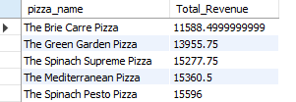

**11. Top 5 Pizza Sold**

SELECT pizza_name, sum(quantity) AS Total_Quantity FROM pizza_sales

GROUP BY pizza_name

ORDER BY Total_Quantity desc;

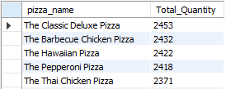

**12. Bottom 5 Pizza Sold**

SELECT pizza_name, sum(quantity) As Total_Quantity FROM pizza_sales

GROUP BY pizza_name

ORDER BY Total_Quantity ;

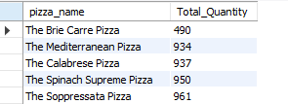

**13. Bottom 5 Pizza by their Order**

SELECT pizza_name, count(distinct order_id) As Total_Order FROM pizza_sales

GROUP BY pizza_name

ORDER BY Total_Order;

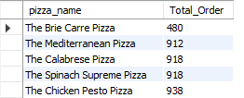

**14. Top 5 Pizza by their Order**

SELECT pizza_name, count(distinct order_id) AS Total_Order FROM pizza_sales

GROUP BY pizza_name

ORDER BY Total_Order desc;

